**PFP**

**Spec** – BJCNDL864-100ST **Naming** – **F**(S or R) {address} **PFP**

BJCNDL576-100ST F – front, S – side, R – rear

BJCNDM432-100ST

BJCNDS288-100ST

**Handholes** (UUB)

**Spec** – HH17x30x24 **Naming** – **F**(S or R) {address} **HH** -

HH30x48

**Spec** – HH10x15x12 aka Flowerpot

**Naming** – FP {house address and abbreviated street}

**Conduits**

**Spec** – 2” SDR-11 Smooth-Wall Orange **Name** – 2.0” CONDUIT

**Spec** – IDUCT 1.25 W TAPE **Name** – 1.25” CONDUIT *(I personally also use 1.25” DROP DUCT for drops to differentiate between the 2 but not sure its necessary)*

**Terminals**

Spec – EVOLV6###RAW Naming - **F**(S or R) {address} – matching UUB

EVOLV12###RAW

EVOLV425RAW (temporary use to avoid errors – not orderable)

**Fiber Cable**

Spec – 5B92MT-024 Naming - PONXXXX

5B92MT-048

5B92MT-072

5B92MT-216

5B92MR-288

5B92MR-432

5B92MR-864

5B922R-1728

Spec – 6F Tail Naming – **FST-TAIL** {terminal name}

12F Tail

*** added task – placing fiber within conduit

Before (wrong) –

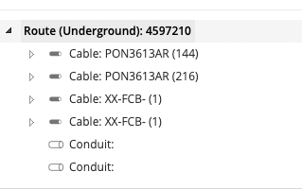

After (right) –

